Picking up New Construction

After you locate the parcel you will be working on, this will be your main screen.
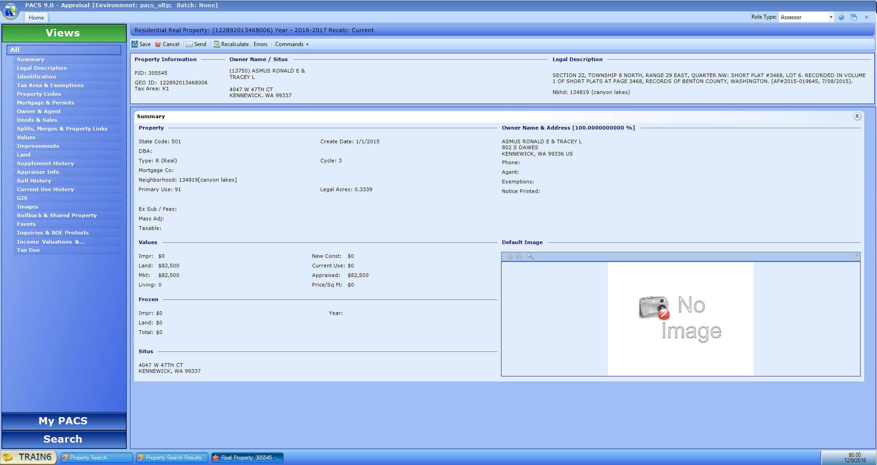

Under the “Views” panel on the left hand side is where you will be switching between screens:
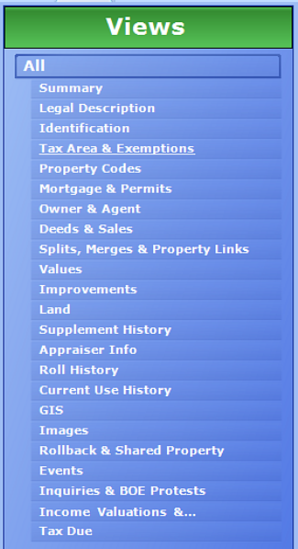
The screen that is showing is the “Summary” screen. If you click on events, you will see where the notes from ProVal have been transferred over:
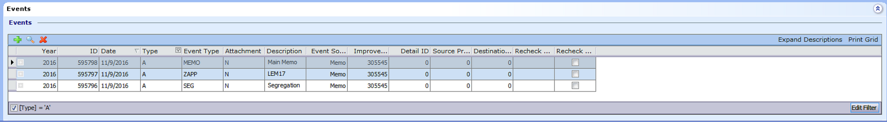

(Information about where to enter notes to come)
Click on “Improvements” on the left and click on the green + icon under Improvements (not improvement details):
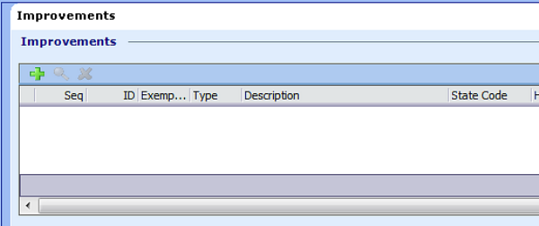
This will bring up the New Improvement window:
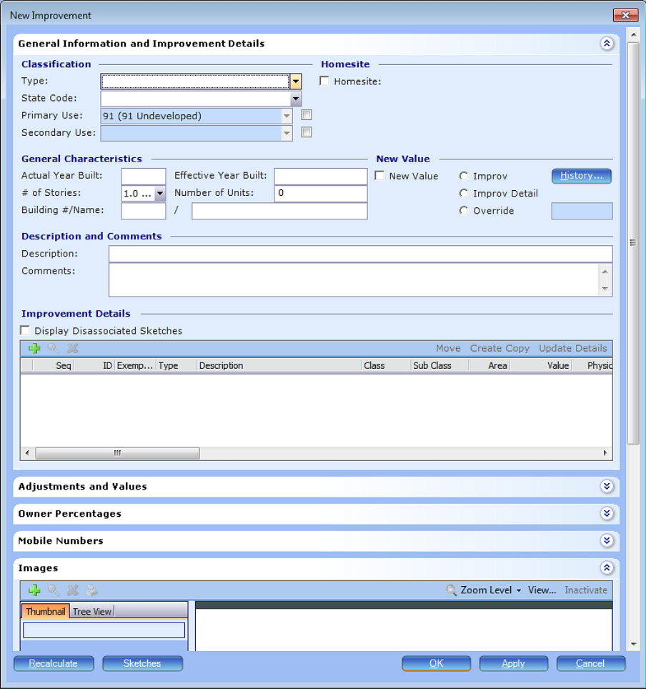
Type will be either Residential or Mobile Home.
State Code is the PCC (which may not be used moving forward). Currently has to be selected.
Primary Use is the use code referenced by the State. For example 11 is an SFD.
Enter the actual year built and select the number of stories.
From this point you can either sketch or enter the details on the home. If you enter the details, they will be available in the sketch to associate as you draw. If you sketch first, you will need to go back into the sketch after entering the details to associate each portion to the sketched areas. If no improvement details exist, you will need to create them first.
Click on the green + in Improvement Details:
